THOMAS TALLIS
Unit 1 (6GEO1) Going Global
Class Notes
Miss Wells

Contents
What is Globalisation? 3
The Role of the TNC 6
Transnational corporations: Case studies: Fender 8
Wimbledon tennis balls: A global product. 11
McDonalds: Global products and global brands 12
NIKE – Case Study of Ethics 14
Global Groupings 18
Trade Blocs 21
Global Networks 22
EasyJet - A Case Study 31
Roots - Population 33
Migration 37
Eastern Europe –Case Study in Migration 39
World Cities 43
Mumbai A Case Study 45
Megacities and Sustainability 48
Managing Change: Global Futures……………………………………………………..………………………………………………47

What is Globalisation?
IMF definition:
“Growing economic interdependence of countries worldwide through increasing volume and variety of cross border transactions in goods and services, freer international capital flows and more widespread diffusion of technology”

Interdependence

- Something that happens in one country will quickly influence happenings in another country.

How does Globalisation happen?

Is it a new thing?

- Great Britain ran a series of networks around the world, The East India Company being the first truly global business
- Raw materials from colonies
- Rapid communication via telegraph wires underwater
- Shared head of State
- Global military power
- Imposing a shared culture

Economic Globalisation

- Growth of TNC’s. Global presence with a global brand.
- Spread of FDI (Foreign Direct Investment) and growth in world trade

Cultural Globalisation

- McDonalds are present in 120 countries with 30,000 restaurants ensures people eat similar food.
- CNN news means people hear similar news

Political Globalisation

- Dominance of the G8 Western democracies in decision making and the view that democratic, consumerist societies are the way we should ‘aspire’ to.

G8
Canada | Japan
France | Russia
Germany | United Kingdom
Italy | United States

Demographic Globalisation

- Increasing mixing and migrating of populations.

Environmental Globalisation

- The realisation that damage to environments require global solutions

Factors accelerating globalisation

Free Trade | Promotes an increase in trade
International Organisations | WTO, trade Blocs encouraged free trade between groups
Oil Money | High Oil prices in 70’s promoted wealth in OPEC countries who loaned to LEDC’s creating and boosting industrialisation
TNC’s | Shifting production to LEDC’s creating global connections and networks
Communications | Internet, telecommunications improvements have reduced communication costs.
Transport | Increase in containerisation , cheap air fares have revolutionised transport
Financial deregulation | Government controls have decreased on banks, interest rates and currencies. Making investment easier and therefore higher profits
Consumers | Global consumers have increased demand over the world for different products and services
The Media | Helped to connect the world and increase ‘similar’ thinking about what people ‘should’ want.

Opportunities

- Great wealth has been created by trade. China’s exports went from $200m in 2000 to $1,000m in 2007
- FDI has created wealth (China increased from $4 billion to $64 billion between 1996 and 2006)
- Individuals benefited from migration to economic hotspots like Dubai
- Developed world economies have added knowledge and education which has helped developing countries
- ‘Poaching’ key employees from all over the world.

Drawbacks of Globalisation

- Leads to inequality – Rich have grown richer poor have got poorer.
- Govts and TNC’s reduce the role of the individuals making them feel like ‘pawns’. Reduction in trade Unions – increase in exploitation
- Encourages unsustainable economic growth with negative costs.
- Westernized global culture

Population

- Globalisation causes migration for mainly economic reasons
- Often legal and illegal
- Migrant stock = 130 million in 2006 (80 million in 1970)
- 30-40 million illegal migrants
- 8-10 million refugees
- 25 million internally displaced people

Illegal Movements
The USA | Major flows from Mexico, approx 10 million illegal migrants
EU | Upto 5 million illegal immigrants across the Southern fringe including Spain, Malta and Italy
Middle East | Attract migrants from Southern Asia to work in construction and domestic service

The Role of the TNC
Definition

“A firm which owns or controls production facilities in more than one country through direct foreign investment”

What are they?

- Large economically powerful and politically influential as well as important creators of wealth
- Large TNC’s have turnovers in excess of some large countries
- Often companies employ tens of thousands of people
- This allows them to wield power
- They are often seen as a blessing and a curse

Size isn’t everything

TNC | Turnover ($Billions) | Employees | Equivalent country GDP ($Billions) | Equivalent city size
Exxon Mobil | 390 | 81,000 | Indonesia (410) | St. Helens (100,000)
Wal-Mart Stores | 374 | 1.7 million | Taiwan (375) | Phoenix Arizona (1.6 million)
General Motors | 203 | 323,000 | Portugal (219) | Cincinnati Ohio (330,000)

Pros and cons of a TNC

Pros |  | Cons
Jobs | Thousands of jobs are created by many TNC is less wealthy countries | Exploitation | TNC’s often accused of exploiting workers in LEDC’s
Trade | China’s economic growth is a direct result of FDI from TNC’s | Unemployment | Developed countries often lose out to LEDC low wages
Connections | TNC’s create global networks and connections that can tie local and national economies into the global system | Identity | Local cultures and traditions can be eroded by western ideas and brands (Coca cola)

Costs and Benefits

- Attracting FDI from TNC’s is a good way to increase opportunities for employment without Govt’s having to spend great deals of money
- Many TNC’s have shifted production to the developing world at the expense of developed countries this is called “Global Shift” or “De-industrialisation”
- Unemployment follows in developing world as can be seen from UK in the 1980’s and 1990’s

Cost Benefits of TNC’s

 | COSTS | BENEFITS
TNC Source Country (Developed World) | Job losses due to outsourcing | Pollution is ‘exported’ from factories overseas
 | Abandoned factories create derelict land (LDDC) | TNC growth leads to higher profits and more tax paid
 | Outsourcing countries can suffer from negative media coverage | Strong global companies are successful creating jobs and developing
TNC Host country (Developing World | TNC’s may pay no or low taxes | Economic growth due to job creation and consumption
 | New locations become polluted as environmental laws are weak | Falling poverty levels
 | Low wages, long hours and exploitation mean poverty and ill health | Local supply chains maybe created
 | TNC’s may force local companies out of business | TNC demands infrastructure and communications which benefit locals

For all case studies students should have:

- Home country:
- Market Area:
- Employment and turnover figures:
- Locations of production and sales
- Issues:

Transnational corporations: Case studies: Fender
(Case Study good for global shift, TNC movement and cost reduction from cost of labour)

The roots
- Fender began in Fullerton California in 1945
- Owner and electronics expert Leo Fender began producing an experimental range of music amplifiers and solid bodied electric guitars, starting with the Broadcaster®.
- Two further models — the Stratocaster® and Telecaster® — became runaway success stories.
- By the 1960’s they had become the must have guitar for musicians

The Fender Brand

- By the 1960’s Fender was supplying guitars overseas.
- British guitarists wanted the ‘Strat’ and ‘Telecaster’ made famous in America
- Eric Clapton, Jimi Hendrix,

The Brand had legs

- Many famous bands were using the Fender guitar which made it ‘cool’ and wanted throughout the world

The Company

- Leo Fender seized the early opportunity of selling his business to Columbia Broadcasting System (CBS) for $13 million in 1965
- CBS was at that time a major US television broadcaster looking to diversify its business holdings.
- As part of a larger company, the Fender brand immediately benefited from worldwide advertising, prompting a global surge in consumption

1970’s – the bubble bursts

- The boom years did not last. By the mid- 1970s, Fender, in common with other US manufacturers, faced a crisis of profitability for several reasons:
- SE Asian manufacturers benefitted from low labour costs
- Asian made guitars were imported into USA that mimicked Fender design selling for much less
- World recession sparked by oil shocks in 1973 and 1979 resulted in higher costs

Fender’s response

- Although professional musicians were still prepared to pay 'top dollar', others were lured away by cheap imported imitations
- Fender had to respond
- CBS responded by:
- Developing a near identical cheaper range under the brand name Squier
- Used cheaper and fewer components
- Moved prod’n to Japan in 1982
- Fender Japan became a company name

1980’s

- Global growth was still slow
- Guitar music had become unfashionable synth bands were big like Erasure and Depeche Mode
- Fewer people were buying guitars
- Whilst US cost cutting had damaged Fender’s reputation and sales to musicians began to fall

1980’s – 1990’s

- CBS rationalised and put Fender up for sale
- A group of employees bought it for $9m
- Fender Musical Instruments Corp (FMIC)
- Canada and Mexico joined NAFTA in 1994
- This meant Fender could send materials to Mexico and have them assembled cheaply before export
- This helped to compete against Asia
- Mexico production began in 1987

Sales Growth

- Guitar music became popular again through bands like Nirvana, Pearl Jam, REM
- UK bands also became popular like Oasis and Blur

Future looks Bright

- New bands are using Fender not only big and popular stadium bands like U2 but also bands like The Arctic Monkeys, Snow Patrol and Beach House

Fordist and post-Fordist manufacturing

- The move to Mexico is important in explaining Fender's recent success
- Prod’n follows Fordist principles
- High output levels for a limited range of relatively inflexible designs keeps the individual unit cost low.
- The ‘Standard’ Stratocasters and Telecasters
- Squier and Fender are rolling off Asian conveyor belts in growing numbers

Post Fordist Prod’n

- Along with the high volume prod’n is the Skilled US craftspeople hand-built expensive customised guitars.
- designed for an elite niche market comprising professional musicians and affluent guitar collectors (from Bill Gates to Tony Blair, plenty of wealthy people play guitar)
- This includes:
- superior high-grade wood and metals worked by hand
- wider ranges of colour and design small batches sold as limited editions
- the artificial creation of a 'distressed' or antique look
- Workforce is skilled and can produce exact replicas of old guitars owned by famous musicians selling for $1000’s

The twenty-first century

- From its humble beginnings Fender has grown to a large TNC
- Buying up smaller manufacturers and obtaining distribution rights for famous guitars like Gretsch and Taylor
- Markets are growing in the new economies of the world
- Asian markets are now growing

Discussion

- Do you think Western guitar music — with words sung in English — can continue to influence culture on a global scale?
- What kind of involvement, if any, do you see Fender having in the African continent during the twenty-first century?

Wimbledon tennis balls: A global product.
(Case study of TNC – Costs of production and global shift)
- There are 48 000 Dunlop Slazenger balls used at Wimbledon each year.
- The materials and labour to make them comes from over 10 different countries.
- From 1940 – 2002 tennis balls were made in Barnsley, Yorkshire.

NOW

- The Bataan factory on the island of Basilan in the Southern Philippines is the focus of production.
- 1970’s Philippine government set up Bataan Economic zone to attract FDI.
- Philippines had cheap, available labour.

Where do materials come from?
- Rubber – Malaysia. Small rubber plantations supply a processing plant near Penang.
- Glue – Philippines. Rubber from Basilan is mixed with petroleum naphthalene to make glue.
- Yellow cloth covering – UK Wool (from New Zealand) and a synthetic mix.
- Tins – Indonesia
- Filler and chemicals (make up 60%) of the core of the ball.
    - Clay - South Carolina
    - Sulphur - Korea
    - Silica - Greece
    - Magnesium carbonate – Japan
    - Zinc oxide - Thailand

Global marketing

Wimbledon men's final has worldwide TV audiences of several hundred million.
- Strategic advertising by Dunlop Slazenger ensures maximum exposure.
- Product is linked to a successful global name (Wimbledon) and all that goes with it.

McDonalds: Global products and global brands
(Westernisation of culture, Environmental impacts of TNC’s and Growth of TNC’s)
- Begun as a burger stand in 1937
- Ray Kroc bought the company in 1955 and franchised the name
- Now has
- 31000 restaurants
- Operates in 121 different countries.
- Serves 46 million customers each day
- Annual turnover $40 billion / year
- 1/3 of all cows reared in the US are used in McDonald burgers
- 8% of US potato crop makes its fries
- 1/8 of US population have worked at McDonalds at some point in their lives
- Between 1965 and 1991 annual growth averaged 24%

Globalisation

- Early expansion was in US market (still account for 55% of profits)
- Rapid expansion overseas from 1970’s
- UK, France, Germany + US (80% of sales)
- 6000 stores in Europe (300 planned in 2003)
- 500 stores in China (100 planned in 2003)

The ultimate global brand?

- McDonalds is synonymous with the American dream and way of life
- Worldwide popularity?
- First UK store opened in 1974 and people queued for four hours to get in.
- Kuwait city queue for the first drive thru was seven miles long.
- Moscow’s Pushkin Square is the busiest store in the world.

The ultimate global product? -The BIG MAC

- Meat is frozen and sent to each store
- Bread is centrally baked
- Fries are mass produced
- Recipe is the same worldwide
- The name is the same!

The ultimate global marketing campaign?

- Marketing operates around the name
- Gimmicks such as Ronald McDonald and Hamburglar exist to sell Happy meals to the future customers
- McDonalds associates itself with major sporting and world events with world media exposure

The ultimate TNC?

McDonaldisation (Ritzer)
- Predictability – Standardises products so that consumers do not seek alternatives
- Calculability – The consumer ignores quality and places importance on cost, cost of time and effort to get a meal
- Efficiency – McDonalds shortens the time between a want and its satisfaction
- Control of humans – deskilling of workers and consumers, fixed menus, limited options, uncomfortable seats, drive thru process etc

The future
- 2003 first loss
- US market saturated
- Expansion into poor LEDC’s where market is too small
- Increasing competition from health conscious foods
- Falling quality ratings
- Few innovative new products e.g. Veggies
- Impact of critical books e.g. Fast food nation
- Impact of anti globalisation campaigners
- The future
- Improve the quality of its products
- Promote foods with higher profit margins e.g... Chicken burger
- Deal with the obesity litigation claims in the USA (won Jan 2003 against a group of obese teenagers from the Bronx)
- Control its global image regarding environmental claims

NIKE – Case Study of Ethics
(TNC Ethics/ exploitation of workers and westernization of products, global shift)
The Company

- Seller of athletic footwear and apparel
- Produces in 45 countries worldwide
- Headquarters in Oregon, USA
- Founded in 1964
- Brand name created in 1971
- Just do It campaign in 1988

Criticism started in early 90’s:

- child labour
- safety and health problems
- physical harming of employees
- Review of Labour Practices in 1995
- Nike’s response to growing criticism

Organizational Structure

Matrix Structure

- Each department overlapped by geographic divisions and product categories
- Overlap in managerial responsibilities
- Fluid leadership structure
- No formal communication link between regional and product heads

Labor-intensive:
-Manufacturing location
-Outsourcing production
-Reassess production methods

Rising crude oil prices: 65% increase in one year
-Transportation, raw materials and energy
-Consumer’s disposable income

Change of consumer taste:
-Athletic shoes - Brown shoes

Globalization

- Opportunity:
-Lower import tariffs/duties
-Access to cheap labor and raw materials

- Threat:
-Increased competition from Asia

Consumer Demographics Sales:

-Ages 30 – 34
-Teenagers & Men (early 40s)
-Men (20s)

Infringement Statistics:

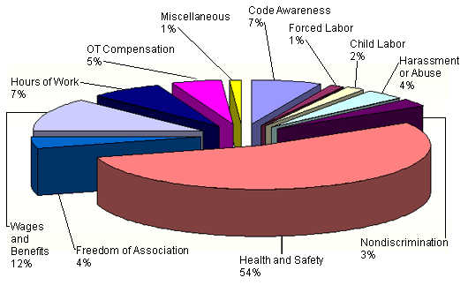

Business Model

Operations:
-Footwear, apparel, equipment
-Other businesses:

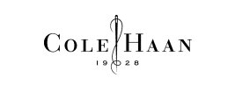

Business-Level Strategy:

- Integrated cost-leadership and differentiation strategy

Resources:
- -Tangible: Fit, Sphere, Air, Shox technologies
- -Intangible: brand name / reputation for innovation

Core Competency:
- Distribution and subcontractors’ networks
- Mass marketing

Competitive advantage:
- Brand name and celebrity endorsements

Bargaining Power of Suppliers:

- Subcontracts to more than 500 small scale factories
- Low bargaining power due to Nike’s big volume

Bargaining Power of Buyers:

- Competitive products all compete on differentiation
- Low switching costs

Threat of Potential New Entrants:
- Economies of Scale
- Strong and Well Established Brand Name
- High Capital requirements
- Low threat

Intensity of Rivalry between Firms in the Industry:

- High competitive in an Oligopoly (other leading firms include Adidas, Puma, Fila, New Balance)
- Strong brand identity and product differentiation
- Intensity of Rivalry is moderate

Partnership / independent organization

Benefits:
- Knowledge
- Credibility

Drawbacks:
- Control surrender:
- Information leakage

Vertical Integration benefits:

- Full control
- More profits
- Drawbacks
- Very costly
- Less flexible

Global Groupings

What do we mean by global groupings?

- How many ways are there to classify countries?
- Wealth (Via GNI)
- Global position (EU)
- Religion?
- Political ideology?

Wealth

- Rich countries have maintained their dominance during the era of globalisation
- A lucky few have joined this group such as the Tiger economies of SE Asia (Singapore, S. Korea and China)
- Economic power is concentrated in three areas N. America, Europe, Asia
- Of the 500 biggest TNC’s 162 are from USA and 67 from Japan
- These core areas are referred to as the TRIAD
- Around 80% of global wealth is concentrated here linked via complex economic pathways, international hubs and Govt’s.

Economic Groupings (GNI)

- Gross National Income (GNI = GDP + income received from other countries - less similar payments made to other countries)
- Dividing the world into the rich north and poor south is common. Done originally by the German Chancellor Willy Brandt

A Complex World

- This is too simple some countries are growing whilst others are stagnating
- E. Europe has seen a fall in GNI whilst N. Africa has seen a rise
- Groupings are useful because they allow us to look at development pathways
- Countries can and do move between groups.
- Singapore was once a NIC but now is a developed country

Economic Groupings

Economic Groupings | Examples | World Bank GNI | Economic Structure
MEDC | UK, USA,  Japan | Income higher than $11,115 | Service based economies. TNC’s based here. Lots of R+D
NIC | S. Korea, China, Brazil | Upper middle income ($3,500 – 11,115) | Service economies with a lot of manufacturing. Primary and secondary inds not as important as once were
RIC | Thailand, Indonesia | Lower Middle  ($906 - $3500) | A lot of primary business, manu’ing growing rapidly develop’t is rapid
LEDC | Egypt, Peru | Low income (< $905) | Primary Industry around 40% + of jobs development is slow
LDC | Bangladesh, Malawi |  | Dependant on primary industry – high levels of poverty, getting poorer in absolute terms

Political Groupings

Grouping | Members | Role | Importance
EU | Formed 1957 – 27 members | Economic union for internal free trade and pop’n movement | 7.5% or world pop’n but 31% of global GDP
OECD | 1961  30 members, all democratic market economies | Ensures rich developed countries run smoothly, tries to reduce corruption and bribery around the world | 75% of GDP generated in 30 member countries
OPEC | 1960  12 major oil exporters in middle east S. America and Africa | Safeguard interests of members and govern price of oil | OPEC has 65% of global oil reserves and 35% of prod’n
G8 | 1974  UK, USA, France, Canada, Germany, Italy, Japan, Russia | Informal forum (The super rich club) | 65% of GDP but only 15% of pop’n
G20 | 2003  21 countries including BRIC’s | Formed to press developed nations to open up markets to developing world trade | 60% of worlds pop’n and 20% of GDP
G77 | 1964  Most African, Asian and Latin American countries (130 in all) | Loose group that forms collective voice of developing world | Influence is lessening as China is no longer member

- This is a more formal grouping of countries called intergovernmental organisations (IGO)
- These are signed agreements for economic gain
- Like minded countries usually at similar levels of development
- Groups protect the interests of member states.

Trade Blocs

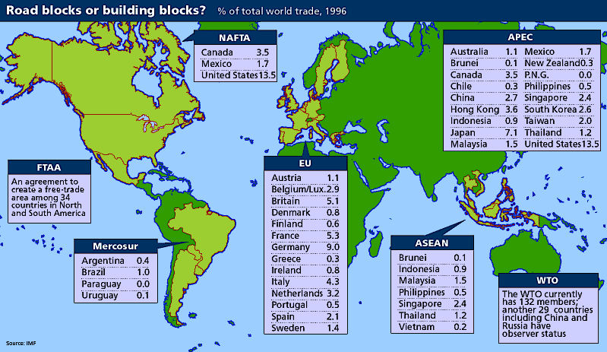

- Allow free trade within member states
- No tariffs, taxes or quotas exist
- Countries outside the bloc often have to pay taxes to get products in
- These external barriers protect the member countries
- WTO work to reduce trade barriers and create free trade. The world gets caught between the two
- Trade blocs have become more common as have free trade agreements
- The general consensus is free trade is good, but there is an unwillingness to drop barriers
- International trade growth have lead to significant shifts in wealth and power
- Developed nations remain in pole position
- Tiger economies have developed very quickly
- BRIC’s have also gained power and wealth
- Many African countries have barely benefitted.

Exam Questions
Suggest reasons why the membership of trade blocs, such as the EU, has changed over time. (10)
Using examples, examine how nations are classified into different types of global groupings. (15)

Global Networks

What do we understand about networks?

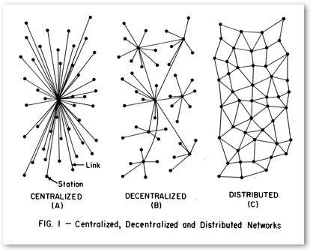

Definitions

- CORE – The most developed and highly populated regions, the growth is fed by the migration of labour from LEDC’s
- SWITCHED ON PLACES – Nations and areas that are globally connected to other places through production and consumption
- WILDERNESS – An area on the planet of relatively untouched by humans and is home to only a few indigenous people e.g. Borneo and Antarctica

A Shrinking World

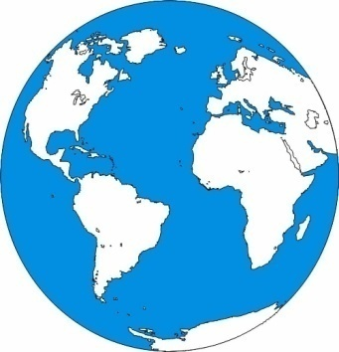
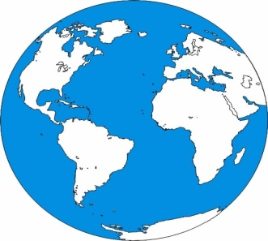
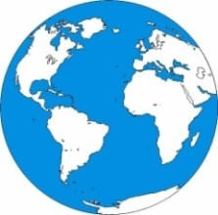

1990’s – 31 hrs in Concorde

1930’s - 8 days to navigate the globe, propeller aircraft

1700 – 2 yrs to navigate the globe in 3 mast ships

Communications Timeline

- 200 AD first sailing ship
- 1500 – 1700 Industrial canals and stagecoach routes
- 1800 – first steam ship (Crosses Atlantic in 29 days)
- 1866 – Telegraph wires laid across the Atlantic
- 1900’s – early Ford Motor car company 1903 / first TV 1926 / first commercial flight 1928
- Late 1900’s – first mobile phones – 1980’s / Internet 1989 onwards.

The growth in telecommunications has aided businesses with instantaneous communication
Broadband has allowed the quick movements of data around the world in seconds
Air Travel pioneer cheap travel for all and movement of large amounts of people quickly
GIS and GPS help to transmit data around the world on locations and pinpoint cargos

Mobile Phone Take Up

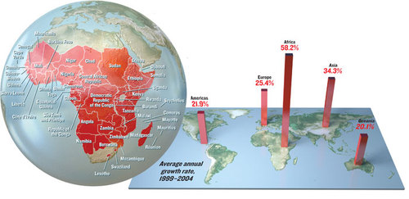

Key Terms

- Cluster – Geographical concentrations of similar businesses
- Cumulative Causation – Wealth becoming concentrated in one area. Globalisation increases this as local people can find markets for their products
- Global Hub – A settlement that has a global influence e.g. megacities.
- Multiplier Effect – Positive spin offs from an initial investment
- Technopole – Cluster of technology lead businesses
- Trickle Down – Positive impacts on the peripheral regions e.g. improved infrastructure.
- Export Processing Zone – Small industrial area usually on the coast that attracts TNC’s due to tax exemptions or over incentives

What Makes a Global Hub?

Natural Resources | Human Resources
Strategic Location that encourages investment | Large Labour force
Oil Resources | Affluence attracts service providers
Physical factors that aid growth such as minerals or relief | Universities
Coastline ideal for trade | Languages spoken

Middle Income Countries

- In rich countries wealth has spread to rural areas whereas countries like Brazil and South Africa still has a large amount of poverty in rural areas.
- Globalisation has in these cases exacerbated these poverty’s
- Nigeria – elite live in Lagos have huge growth and wealth. Ogoni people of the Niger delta have received nothing from the wealth generated from oil extraction in the region

Switched Off Places

- Very poorest nations
- Not connected
- Sudan, Chad and parts of Burma whether rural or urban
- Subsistence farmers rely on OECD and NGO’s for relief
- Farmers may grow for TNC’s but low wages creates no spending power

Global Connections

What is a ‘global network’?

- Global networks seek to connect the world into an integrated whole.
- As globalisation is an old process (in new, accelerating, clothes) they have a long history.
- One of the earliest networks was the Royal Nay in the colonial era.
- It was augmented by new undersea telegraph technology in the mid to late 19th Century:

Are things so different now?
Global networks come in a variety of forms. They can be networks of:

- Business and Trade – physical and financial flows.
- Communication networks – the internet being the clearest example
- Transport networks – air travel and container / bulk shipping
- Production networks – particularly those of TNCs
- Political networks – especially those that focus on economic / trade ties
- Demographic networks – flows of people

2. Whose connected?

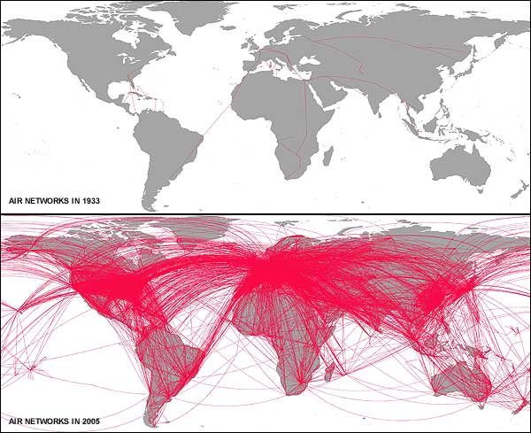
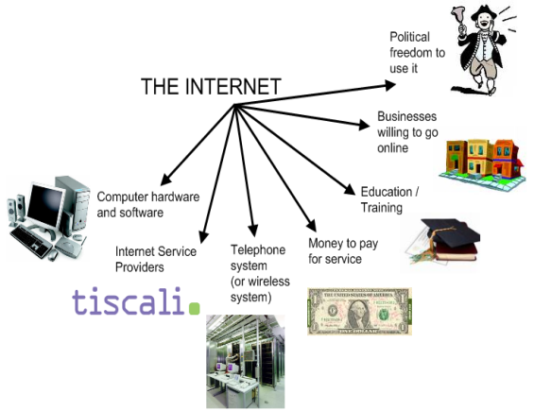
- The internet provides one of the best indicators of connectivity.
- As a technology, it has been adopted extraordinarily rapidly, and has managed to become part of everyday life.
- The internet requires certain key support features which are strongly related to level of development:

- The map below shows internet connectivity by connection density.
- This is related partly to population density, but also to level of development.
- It clearly shows the global economic cores, but barely manages to trace the outline of Africa.

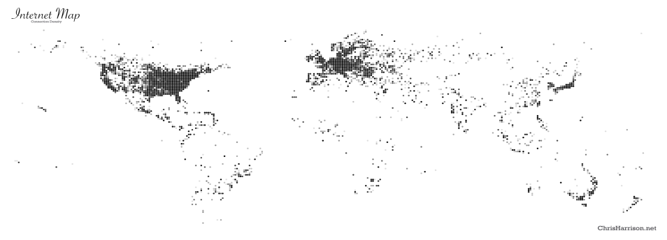

- An easy way to find out who is connected, or not, is to examine the pattern of a major TNC.
- Here is information for MacDonald’s.
- Note the importance of the three global core areas, and the lack of presence in Africa.
- Starbucks reveals a classic network pattern.
- Major retail in its home region, spreading to the 2 other global cores.
- Sourcing of paper from areas where climate permits softwood timber.
- Sourcing of coffee largely from regions where it lacks a major retail presence.

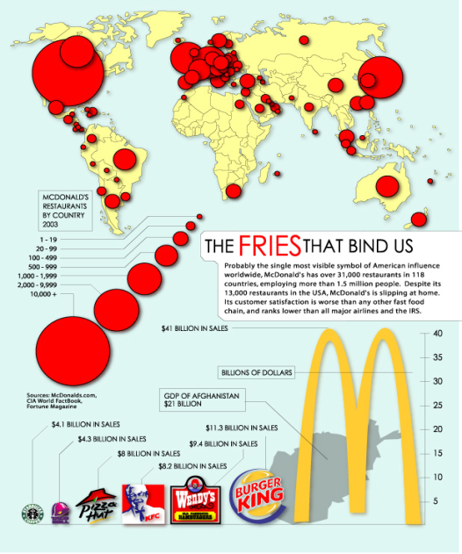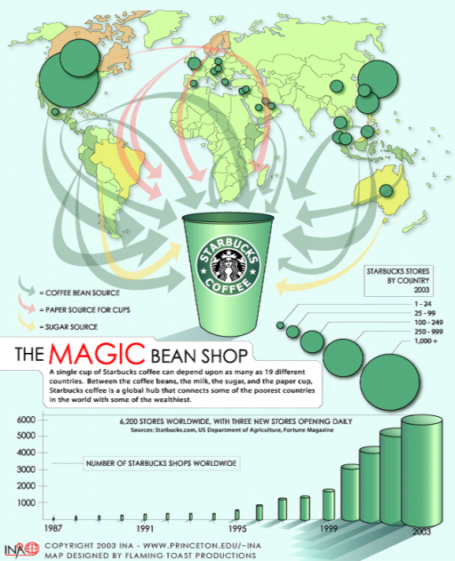
Global Hubs

- Global hubs are ‘cores’ that demonstrate a number of intense connections to the rest of the world. Places that others wish to connect to.
- In some cases these are the obvious World Cities such as London and Tokyo.
- In others, they may possess a particular attribute that others wish to connect with, rather than displaying a full range of connections.
- Many of course, host the major TNCs of the world.
- They tend to be places of increasingly diverse populations are demographic flows, as well as flows of finance, trade and ideas, move towards them:

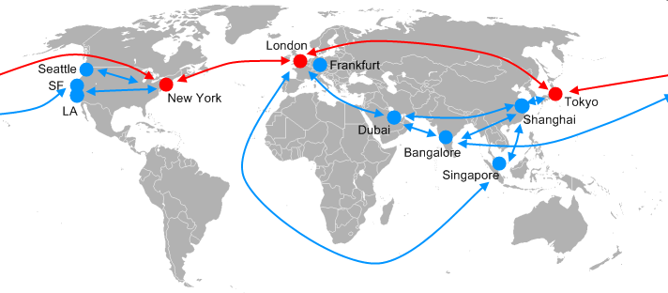
Mega-hubs

- London
- New York
- Tokyo

Hubs

- Dubai
- Frankfurt
- Bangalore
- Singapore
- Shanghai
- LA
- San Francisco
- Seattle

Who’s disconnected?

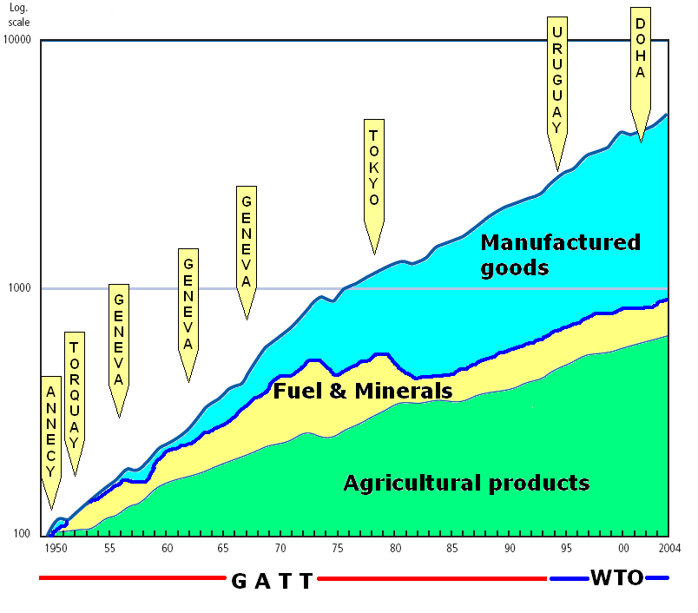
- MEDCs – who have generally maintained their share of trade.
- Asian NICs, who have seen rapid trade growth.
- Africa and Latin America have not benefited.

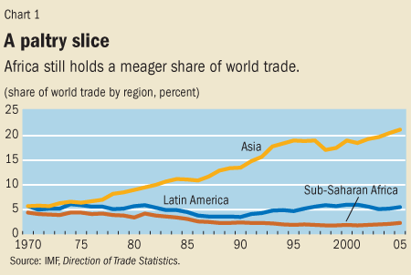

BANANADRAMA: CONNECTING and DISCONNECTING
What’s at stake?
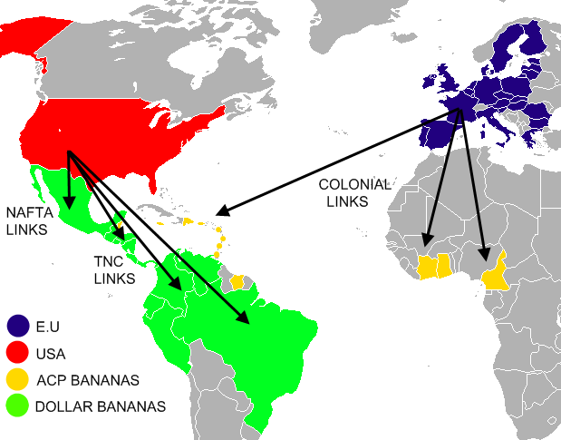

- Traditional connections versus free trade connections
- Developing nations versus some of the most underdeveloped
- TNCs versus small producers
- Cheaper bananas for consumers
- Working conditions and wages

Creating connections?
Major challenge.

- Getting ‘switched on’ to globalisation requires certain key criteria to be met.
- In the past, we tended to think of development in terms of the Rostow take-off model
- Still broadly applicable, although the need for some sophisticated communications technology is increasingly important.
- The global success story in terms of connections is China, with its 15 years of 9-10% annual economic growth.
- How has it plugged itself into the global economy whereas others have failed to do so?

Consequently China has attracted far more FDI than India

CHINA | INDIA
1- A long term strategy of economic reform | 1-Reforms in India have been piecemeal
2- Policies that have not worked, have been changed; pragmatic, rather than dogmatic. | 2- Key issues, such as corruption and red tape
3- Infrastructure building; as a society it is stable. | 3- Governments have tended to change regularly
4- Investment in human capital | 4 - Investment has focussed on some areas, leading to growth poles

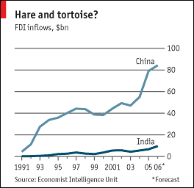
- This has contributed to the fact that China is on the verge of a mass consumption economy, at least in the heavily populated coastal zone.

Boom and bust?

- In the last 2 years in particular, developing world nations have tended to grow strongly
- Much of this growth has been on the back of sharply rising commodity prices, oil, food stuffs and metals. Oil and big food exports have done especially well (Nigeria, Sudan, Argentina, Middle East, Angola).

The $100 laptop?
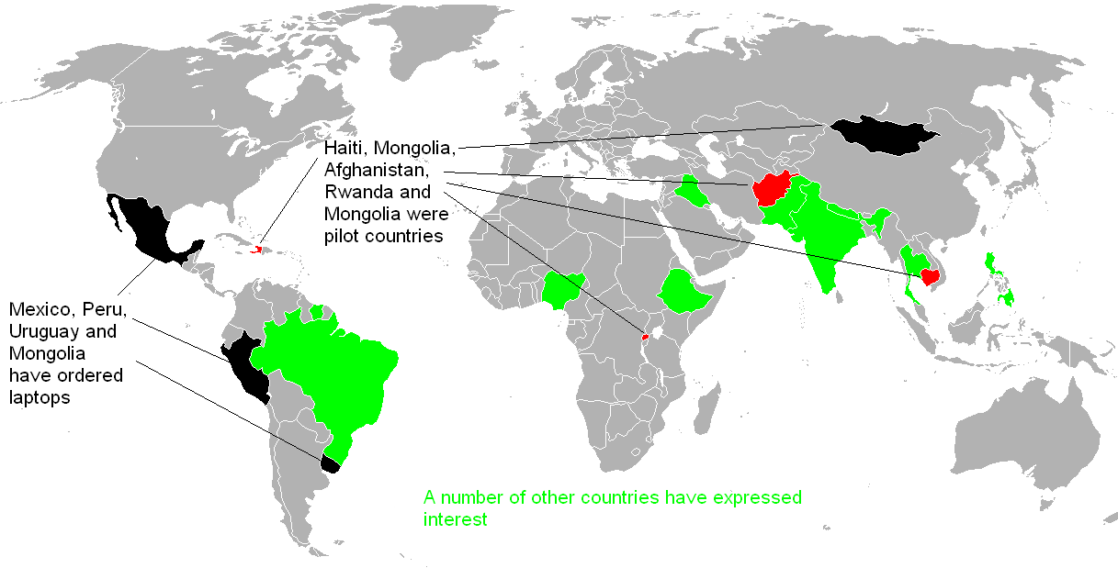

- A major global project to ‘get connected’ is the One Laptop per Child (OLPC) scheme, or ‘$100 laptop’.
- This began in 2005.
- The laptop itself is a wind up machine, using open source software.
- A number of large TNCs donated $2 million each to launch the project, including:
  - EBay
  - Google
  - AMD
  - News Corporation

- It is noticeable that few very poor countries have expressed an interest. The project has been criticised on the basis that:
- The $188 price is too high
- The cost of setup, training and internet access costs are not included in the price
- There are more pressing problems, such as lack of clean water, sanitation and food supply.
- The Indian Government has said, “It would be impossible to justify an expenditure of this scale on a debatable scheme when public funds continue to be in inadequate supply for well-established needs”.
- Some 85,000 people contributed to the ‘Give one Get One’ programme, but it has now stopped.

EasyJet - A Case Study
(Case study on global connections – switched on/off low cost TNC)
- Sir Stelios Haji-Ioannou founded EasyJet.
- Began EasyJet in 1995 as a UK only airline with 2 craft
- It was one of the first airlines to offer no-frills scheduled flights.
- Initially just working from a telephone booking centre at London Luton airport
- first online booking was made
- In April 1998.
- EasyJet paved the way for the boom in low cost air travel to Europe
- Now the 2nd largest budget airline. In 2007 they handled in the region of 37 million passengers
- From Britain, it now operates scheduled international flights from 11 UK airports
- They now have hub airports all over Europe and their number of European flight routes lies close to 400

Making Flights as Cheap as a Pair of Jeans

- Some flights as little as £29 one way
- 1996 saw first flights to Barcelona and from their growth was huge
- 2005 saw its 100 millionth passenger
- Since then began flying outside the EU to Marrakech and Istanbul
- Great Advertising benefitted the company
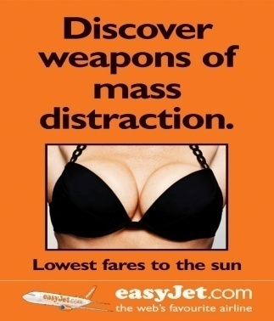
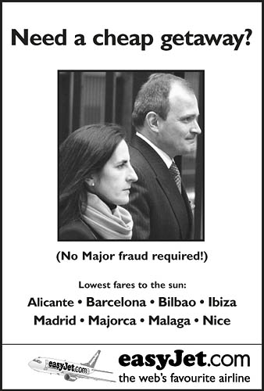

- It was clear a major TNC was developing by 1998 when it acquired a 40% share of the Swiss air company TEA Beal AG allowing it a base in Geneva
- Technology helped to build its global network
- 95% of sales are Online
- Making it one of Europe's biggest Internet retailers

30 January 2007

- EasyJet and Microsoft launch the pioneering “EasyJet desk top gadget.” The two leading technological innovators teamed up for the development of the new Windows Vista and the 2007 Microsoft Office System to create a range of desktop "gadgets" and web services to ensure travel is seamless from desk top to touch down. The "EasyJet desk top gadget" enables customers to personalise flight information and booking services using the Microsoft Vista technology.
2 August 2007

- EasyJet became the first major European airline to offer its customers the opportunity to offset the carbon emissions of their flights by investing exclusively in United Nations-certified projects. All funds contributed by passengers will initially be used to buy carbon credits from the Perlabi Hydroelectric Project in Ecuador.
- By 2006 it owned 122 aircraft carrying 30 million passengers and creating £2 billion in revenue
- Places they fly to become more ‘Switched – On’

Tallinn, Estonia

- October 2004 EasyJet began flying to Tallinn
- Population 400,000
- Flew UK tourist for £40 and city became affordable to visit especially for stag and hen parties
- Apart from a rise in STD and poor behaviour trade has increased in hotels, bars and nightclubs and Tallinn is now a ‘connected place’

Roots - Population

The study of population is called demography

- Changes in the inputs and outputs will change population growth
- Populations are constantly changing and is a dynamic and open system
- Inputs = births and inward migration
- Outputs = Deaths and outward migration
Factors that Influence Our Population

- Cultural
- Political
- Economic
- Environmental

The inter-relationship between these factors can change population in terms of:

- Population Growth
- Population decline
- Ageing Population
- Youthful Population

Ageing Population
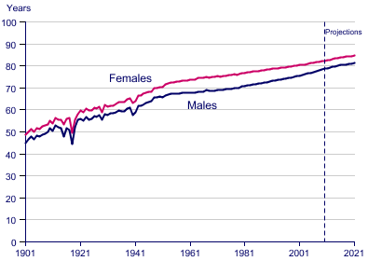
- Already 1.2 million people over 85 in the UK
- As people live longer the population is ‘Greying’
- At the same time
- as people living
- longer less children
- are being born

Greying Population costs

Dependency:

- Economic Costs
- Responsibility and Care

Benefits

- Voluntary and charity work
- Spending money on goods and services
- Earning money and still paying taxes
- Wisdom and knowledge

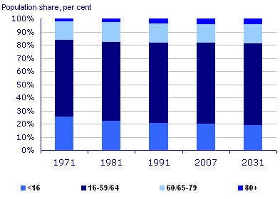
Will Greying go global?

More pensioners than under-16's for first time ever

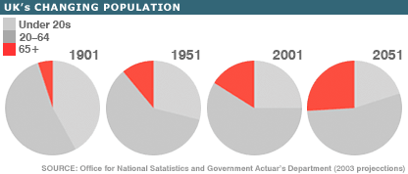

In Pairs
On the graph below pick out the reasons for the various changes in birth and death rates

Factors that affect Structure

Family Size
- Population almost doubled between 1901 and 2007. However growth in household size has fallen
- Many households consist of one or two people
- Increase in life expectancy has lead to an increase in extended family

Migration
- Personal mobility has increased with a general southern drift with now 26% of people living in London and the South East.
- Counter-urbanisation
- Rural Depopulation
Employment
- Decline in traditional manufacturing as well as primary industries making increasing number of people moving areas for work

Social Status
- During this century average wages have risen and more and more are entering higher education. This has lead to more social mobility and peoples’ changing aspirations
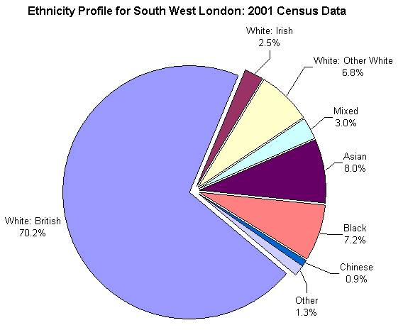
Ethnicity
- The population make-up of the country is changing.
- Minorities represent 8% of our population many of these are from former colonies
- Since Maastricht Treaty 1993 many European Migrants have arrived in the UK
- Segregation has changed the makeup of many of our cities.

An Ageing Population

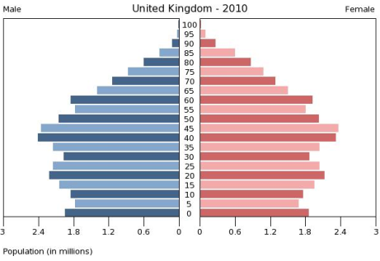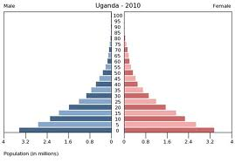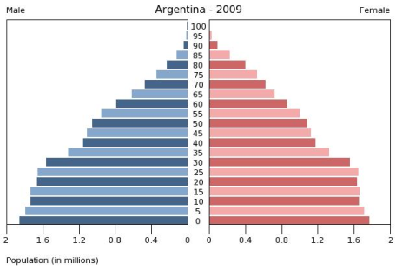

What are the differences between these countries and what benefits and problems do you foresee in the future?

Migration
- International migration is at an all time high.
- In 2001 191 million people were on the move in 2006 3% of the world pop'n (192 million) were moving and more recently more and more migrants have become concentrated in a smaller number of developed countries.
- However there are places where people almost never move.
- A Third of all people do not live in the country where they were born.
- That number should grow as aging rich societies run short of workers, which should be a boon for development.
- Workers who have migrated from poor to rich countries already send billions of dollars back to their families each year (REMITTANCES), a flow that surpasses foreign aid.
- Some immigrants from developing countries, especially students, pick up skills and bring them home—engineers and physicians as well as entrepreneurs who, for example, start computer businesses. These numbers have increased due to economic globalisation.
- Statistics show that the poorest people tend to remain in their own country and that the educated, professional people are the ones more likely to move.
- Skilled and educated members of the pop'n in the Source nation are more aware of the opportunities overseas, and are able to move of fill job shortages within the host nations.
The impact on the Host Nation
- Voluntary migration is the basic flows of labour.
- The host nation gains because it helps to fill gaps in the labour markets with the new workers often prepared to work for less money.
- In 2002 the UK govt expanded its Highly Skilled Migrant Programme which is intended to:
  - attract the brightest and best foreign workers
  - fill skills shortages
  - Attract lower or intermediate skilled migrants
  - Balance the UK's own ageing pop'n

- But it's not just the UK who wants these workers they have to compete with other nations such as Australia, New Zealand, USA, Canada and some other European countries.
- The expanding global trade means that leading nations require skilled ICT bods and business minded workers in order to compete in the world economy.
The Impact on the Source Country
- One of the main benefits for the source country is the amount of money that gets sent back (Remittance) by the migrants.
- The World Bank estimates this to be in excess of the amount given in aid to individual countries (Up to $233 billion in 2006 this provides vital income for the families left behind.
- However there are downsides. Migrants are usually the most skilled and so effectively a Brain drain begins and this slows down the development within the source country.
  - Some of the migrants work is low pay, low skilled and seasonal
  - it helps reduce unemployment in the source country
  - Can reduce fertility rates
Connections and Hubs
- The twentieth century has seen the opening up of airspace and cyberspace to millions of people around the world.
- Falling costs and the increase in availability means that networks of communications bring people and places closer together.
- Well connected places feel the full impact of globalisation.
Digital Divide
- Rapid movement of data and communications brings people closer together but slow or no movement seems to push people apart this creates a Digital Divide African nations such as Uganda remain 'Switched Off' with many people outside the realms of the internet or digital age.
- Africa had 34 million internet users in June 2007 compared with 437 million in Asia and 322 million in Europe.
- Isolation increases the gulf between the have and the have "nots".
- It can however also protect areas from westernisation from culture and influence not always wanted and preserves the uniqueness of a place.

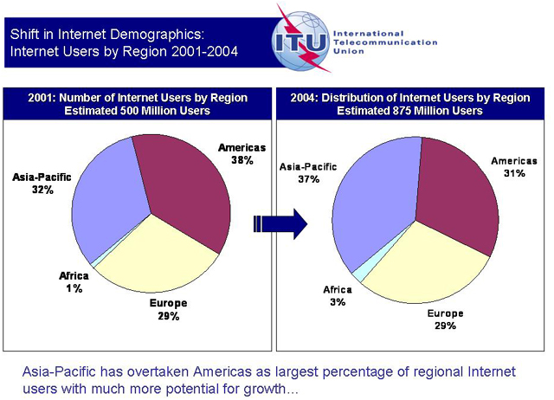

Eastern Europe –Case Study in Migration
(Case Study into the movement of Eastern Europeans into Western European countries – COMPULSORY CASE STUDY)
PUSH PULL FACTORS
PUSH | PULL

Cost to Host Nation

Benefits to host nation

Costs to Source Nation

Benefits to Source Nation

Case Study: Spain
(Case study in migration to hotspots for climate and higher S of L)
- Spain's pop'n is growing by around 2% a year - 910,000 people of which only 220,000 are from natural increase the rest are migrants foreign residents make up 9.3% of the pop'n of Spain – (4.1 million Jan 2006)
- The Spanish govt believe that immigration creates many benefits for the economy.
- Spain like many other western societies is suffering from an ageing population and its fertility rate is low and the govt is concerned that that the indigenous pop'n will soon be too small to create the strong and educated workforce necessary to be successful in the global economy.
- It has therefore encouraged the migration of both skilled and unskilled workers.
- Nearly 65% of all immigrants coming into Spain are between 16-44 so they all can effective contribute to Spain's economy.
- By and large the majority of the migrants are from Morocco followed by Ecuador and other S. American countries which reflects Spain's colonial past.
- Many of these countries are Spanish speaking and families have links with Spain so migration is natural.
- Many migrants are also from countries within the European Union including significant numbers of skilled workers, business people and retired people from the UK.
- However Spain cannot recruit enough people for the low paid work they have available jobs that are dirty, dangerous and difficult such as farming or construction and so accepts migrants from outside the EU.
- Some of these are seasonal workers with permission to stay for 6 months or less and come in as members of SAWS (Seasonal Agricultural Workers Scheme) this allows people, mainly students from countries such as the Ukraine, Moldova and Belarus to work within the EU for short term periods.
- Most of the migrants concentrate along the Mediterranean coast and in Madrid.
- Some areas of Alicante have over 40% non indigenous residents. The concentration of retired people in some coastal areas has caused concern:
- The Overseas retired people have not integrated with the local pop'n. Living in small Enclaves with little social contact with the Spanish inhabitants.
- Puts enormous strain on the already burdened water supply. Local farmers are concerned that tourist and residents are taking too much water for non essential use
- Reduction in the amount of fertile soil near the coast where the land has been sold for development to house the new residents.
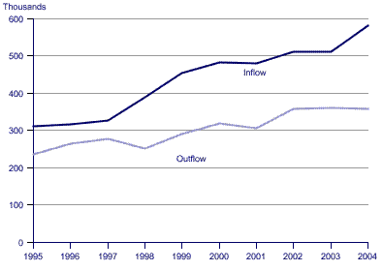

World Cities

Rural Urban migration

- Cities grow from internal growth where rural areas and natural increase feed cities.
- Most of the people who move to cities from the countryside are young fertile people who therefore cause a high birth rate within the cities, this migration feeds city growth.
- The poorest areas of the world have the fastest urban growth
- migration is the largest part, this is even more the case when one city dominates the country these type of cities can often grow at around 7% per year
- Much of this growth is in the form of slums
- By 2020 the number of people living in slums in the developing world will reach 1.3/1.4 billion

Why do people migrate to Cities?

PUSH | PULL

Types of Migration

- Many rural – urban migrants are well informed about the cities they are moving to, the process is not ‘Blind’
- The majority are young and relatively well skilled. Often aware that life in cities is not good
- They realise their prospects with staying are worse
- Fundamentally it is an economic decision

Is it the Right decision?

- In Kenya figures suggest it’s a better quality of life in urban Kenya but not in the Nairobi slums.
- Many know they will have to live in the slums but expect there to be more opportunities than in rural areas.

Questions
- In pairs put yourself in the position of a rural Indian and decide what factors would make you leave or stay where you are.
- In pairs think about the push and pull factors in an urban slum
- Write down reasons why you think some cities become global cities (Mega-cities)

Mumbai A Case Study
(Case study into issues of a world city and plans to develop/ sustainability)
Facts

- Mumbai is the largest City in India
- Mumbai was formerly Bombay
- Natural harbour in the opening of the Thane Creek
- 650 sq km of island
- 484 sq km is densely populated
- 14 million people

Reasons for Growth

- Generates 33% of tax revenue
- 40% of all international flights
- Centrally positioned in Asia
- Easy access to West and China
- Global hub for TNC’s
- Local TNC’s growing faster than TNC’s
- E.g... Tata Steel, Godrej Retail
- Centre of Bollywood

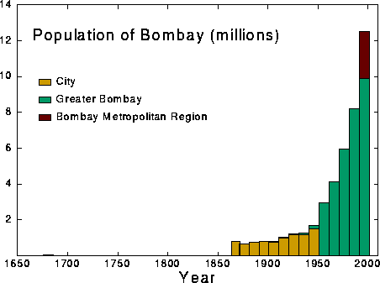

Issues

- Growth has caused high population density and overcrowding
- Old and overcrowded transport system
- Acute shortage of water

Dharavi

- 60% of people live in poverty
- Many live in Shanty towns
- Dharavi is one of the biggest in Asia
- Well organised and some say successful
- Dharavi covers 220 hectares of land near the airport and an estimated 100,000 people live there
- Produces $500m worth of goods

Mumbai – The Vision
Transport

- 11 million people travel daily by Public Transport. (Rail- 48%, Bus- 44% & Private Vehicles - 8%).
- Inadequate road network is slowing down the traffic causing chronic road congestion & Environmental pollution.
- Suburban rail traffic increased by 6 times while the capacity increased by only 2.3 times.
- 4500 passengers travel per train against the carrying capacity of 1750 resulting an unbearable overcrowding.
- Vehicular growth Increased from 61,000 to over 1.02 Million in the last four decades.

Main objective is to provide a rail based mass transit connectivity to people within an approach distance of 1 to 2 km; to serve the areas not connected by existing Suburban Rail System
To provide proper interchange facilities for connectivity to neighbouring areas
Total length by 2021 = Total Length 146.5 km
Done in 3 stages
Mumbai – The Vision
Housing

- Massive cleanup of city’s housing since 2004
- 200,000 illegal slum dwellers moved
- 45 shanty towns destroyed
- Dharavi is to be redeveloped – 7 storey apartments to be built to re-house dwellers
- Non-polluting local industries encouraged to continue with help and premises supplied as well as sustainable strategic help
- Redevelopment is in private hands with developers receiving 1.3 sq m’s for commercial property for every sq m of housing they build.

Mumbai – The Vision
Environment
- 325 new green spaces to be built
- Maintained through corporate sponsorship
- 300 extra public toilets to ease sanitation issues
- Mumbai – The Vision
- Employment
- City needs a growth rate of between 8-10% to succeed
- Hopes to create 200,000 service sector jobs (Healthcare, finance and entertainment)
- 200,000 jobs in new industrial zones around the port and airport (PC assembly and fashion)
- Construction – 500,000

The Vision

- By 2013 Mumbai should have wide roads, efficient trains, buses, beautiful seafronts and gardens.
- Better public utilities
- If it succeeds it will become a major player in the global network/ economy and provide a healthy environment and place to live.

Megacities and Sustainability

Can they be sustainable?
- To become a world hub urban development must involve social and environmental development
- Depends on good governance

Can be unsustainable because:

Lack of adequate housing

- Poor health/ Sanitation
- Weak urban governance. Lack of will and resources
- Environmental quality – poor infrastructures
- Poverty – low wages and underemployment

Ecocities - Transport and Environment
- Developing cities often have extremely poor air pollution
- In 2007 Calcutta reported 70% of pop’n had respiratory problems caused by SPM (Suspended particle matter)
- WHO said pollution is so severe that a brown cloud shrouds much of SE Asia for most of the year.
- Reducing this means heavy investment in infrastructure

Examples of Pollution

Mexico City

- cars are banned from the city one day a week according to the digits on their number plates (Hoy no circular system) Beijing tried this in 2007

Delhi

- All buses and rickshaws were converted to cleaner compressed natural gas in 2002
- Strict emission controls since 2000
- Many old lorries were banned
- Since 1997 SO2 has fallen 35%

China

- Shanghai opened the Maglev railway system in 2001 connecting Shanghai to the airport

Brazil

- In Curitiba (SE Brazil) uses innovative approaches to curbing pollution
- Low cost express bus lanes used by 85% of people
- Community led recycling schemes and provision of parking

Sustainability

- The idea of a sustainable city is not achievable by most developing countries especially in Africa
- The focus is on basics supported by NGO’s and international aid.
- Maturing developing cities are better suited to start to reduce pollution
- Curitiba in Mexico comes closest to meeting this ideal but it is small with only 3 million people (Similar to the combined pop’n Greater Manchester)

Dongtan

- At the mouth of the Yangtze river in China
- First eco-city.
- Being built by Shanghai Industrial Investment Corporation
- Aims to create a low energy city that is close to being carbon neutral

Managing Change: Global Futures

We are presented with a set of problems in terms of our global future

- Do we live beyond our means?
- Is our ‘Ecological footprint’ to big?
- Do we need to grow a global conscience?
- Should we develop a sustainable future?
- Is free trade or fair trade the way forward?
- Re-use, reduce and recycle

Living Beyond our Means

- In the developed world we have what we want and anytime we want it.
- Strawberries in winter
- Apples from Fiji
- Resources around the world are used to fuel our appetite for ‘things’
- Our global ecological footprint is rising

The UK

- We are second only to the USA in consuming natural goods and resources
- Only the USA is ahead of use
- If the whole world were to consume like use we would need the equivalent of 3.1 earths’ worth of resources

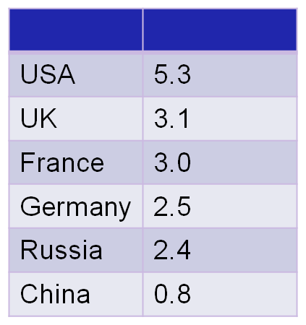

Ecological Footprint

Definition:
- A measure of the amount of land and water that a population needs in order to produce the land and resources it consumes and to absorb it’s waste, with existing technology

Global Conscience

- As we become more globalised we begin to look more outward across geographical boundaries
- Improvements in communication means we can all witness events at the same time
- 3.9 billion watched the Athens Olympics
- Many millions watched the Live Earth Concert in 2007
- We are becoming more aware of worker exploitation
- Impacts of global debt
- Environmental damage
- We are developing a ‘Global conscience’

What woke our Global Conscience?
Events such as:
- 1970’s Oil crisis
- 1980’s debt crisis
- 1985 – Live Aid
- 1992 – Earth Summit in Rio adopted agenda 21 (Sustainable Development at various levels)
- 2006 – Stern Review
- 2007 Live Earth Global Concert on climate change

Fair trade or free trade?

Free Trade

- Where we persuade countries to drop their barriers to trade.
- Free trade generally means that workers and growers of commodities get less for their products

Fair Trade

- Aims to give them a greater proportion

Ethical Shopping

Considerations

- Buying fair trade products
- M&S
- Co-op
- Supermarkets label food and more money goes to local producers e.g. Coffee and tea
- Estimated that all food eaten in UK has a food miles of 30 billion
- In the average kitchen in UK was 41,000 (twice the globe)

Issues

- Producing organically uses more land and can cause deforestation
- Less fertilizers etc means more land needed
- Using local means reducing food miles but the increase in travel offsets bulk delivery to supermarkets
- Food miles aren’t all bad. Food production is less energy intensive in Africa even if flown in
- Buying local can undermine fair trade and poor countries lose out

Carbon Offsetting and Trading

Carbon credits can be voluntary or certified

Voluntary:

- Payments or projects which offset emissions with equivalent savings of CO2
- Coldplay planted 10,000 mango trees in Karnataka India to offset the emissions from production of their ‘Rush of Blood to the Head’ album.
- Besides which after a year most of the trees had died in the dry season and smallholders had lost land in the process

Certified Carbon credits
- International exchanges of
- credits aiming to cut emissions globally
- Allows high polluters to continue polluting while buying credits off those who don’t

Reduce, re-use, and recycle

- Londoners produce 3.4 million tonnes of rubbish a year
- Around 80% of our rubbish can be reused, recycled or composted
- 90% of what we buy becomes waste within 6 months
- In London that’s a tonne/person/year
- Landfill sites are running out and pose environmental risks
- Incineration reduces waste by 75% in weight and 90% by volume
- Incineration leads to greenhouse gases
- Recycling is cleaner, greener and provides new raw materials
- Collection, sorting and processing still requires the use of energy more so than simply producing less waste in the first place
- Composting produces humus that improves soils

