May 2012
7 Study Figure 7.
(a) Suggest reasons why the strongest earthquakes are not always the most costly. (10)
(b) Explain how physical factors lead to a range of hazard risks in the Philippines. (15)
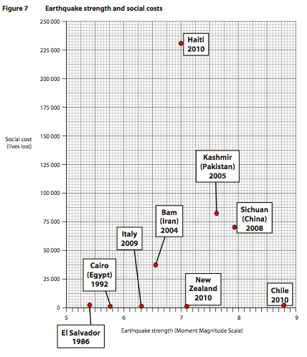
8 Study Figure 8.
(a) Suggest reasons why the populations of different countries vary in their attitudes towards climate change.
(b) Explain why the impacts of global warming are predicted to be uneven and unfair. (Total for Question 8 = 25 marks)
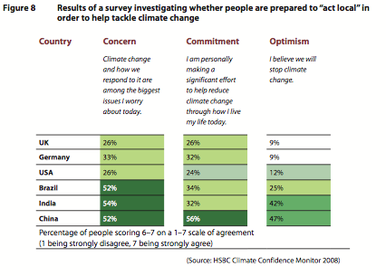

9 Study Figure 9.
(a) Suggest how globalisation increases migration flows towards megacities such as Shanghai.
(b) Explain how technology and trade blocs have contributed to globalisation.
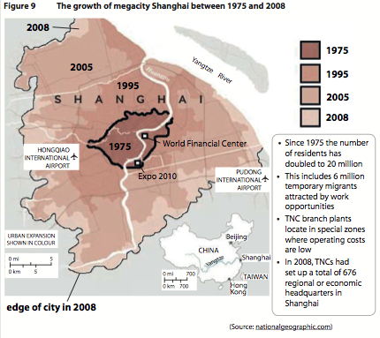 (Total for Question 9 = 25 marks)

10 Study Figure 10.
- (a) Suggest how recent international migration has changed the structure and characteristics of the UK’s population.
- (b) Examine the changing pattern of migration into the UK since the 1950s.
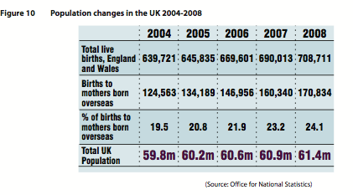

June 2012
7 Study Figure 7.
(a) With reference to the factors shown, suggest how hazard vulnerability in a local area can be assessed.
(b) Explain the global distribution of two major hydro-meteorological hazard types.
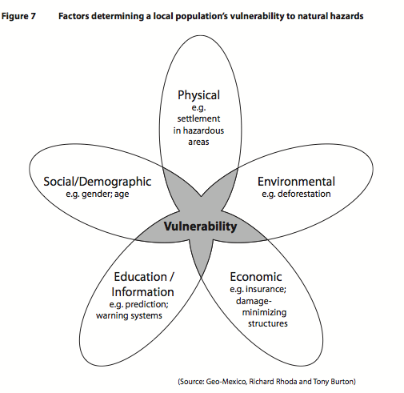

8 Study Figure 8. A) Examine how historical data such as this can provide evidence for natural climate change.
(b) Explain why many scientists believe that human, rather than natural causes, may be more to blame for recent climate change.
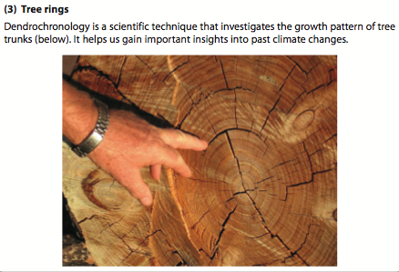

9 Study Figure 9.
(a) Suggest why increasing numbers of people support green strategies such as this.
(b) Examine how globalisation can have both positive and negative effects on people.

10 Study Figure 10.
(a) Suggest why the arrival of newcomers can result in severe housing problems for megacities.
(b) Using examples, explain the causes of rural to urban migration that feed megacity growth

